**MATHEMATICS SPECIALIST**

**MAWA Year 12 Examination 2017**

**Calculator-free**

# Marking Key

© MAWA, 2017

**Licence Agreement**

This examination is Copyright but may be freely used within the school that purchases this licence.

* The items that are contained in this examination are to be used solely in the school for which they are purchased.
* They are not to be shared in any manner with a school which has not purchased their own licence.
* The items and the solutions/marking keys are to be kept confidentially and not copied or made available to anyone who is not a teacher at the school. Teachers may give feedback to students in the form of showing them how the work is marked but students are not to retain a copy of the paper or marking guide until the agreed release date stipulated in the purchasing agreement/licence.

The release date for this exam and marking scheme is

* **the end of week 1 of term 4, 2017**

**Question 1**

|  |
| --- |
| **Solution** |
| Separating variables gives that    and so  Since  when  then.  Hence |
| **Specific behaviours** |
| 🗸 separates variables correctly  🗸🗸 integrates each side correctly  🗸 evaluates the constant correctly |

**Question 2**

|  |
| --- |
| **Solution** |
| The function is odd as .  Now as  clearly have that .  Also    which indicates turning points at . Also. |
| **Specific behaviours** |
| 🗸 identifies correct behaviour for large values of  🗸🗸 differentiates using the quotient rule  🗸 identifies the turning points  🗸🗸draws a neat sketch with a function with a properly identified max/min and being odd in |

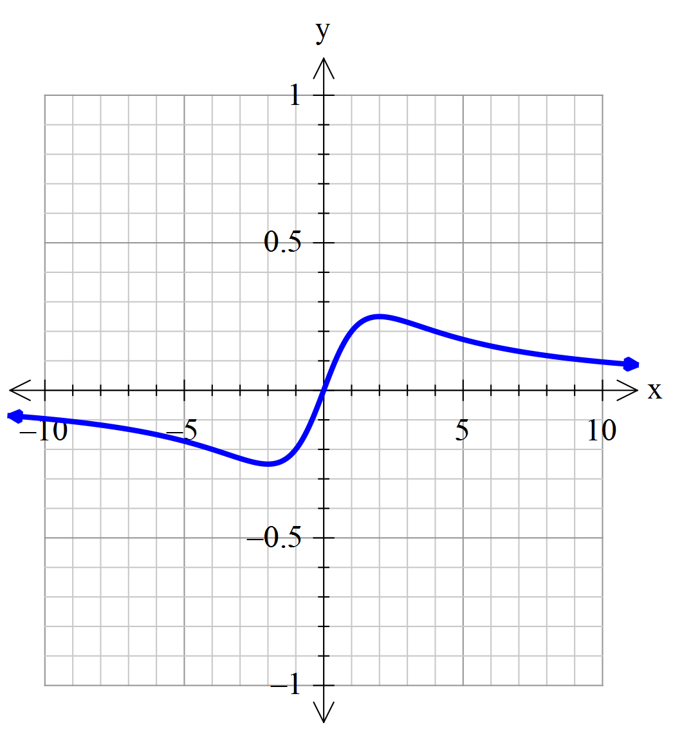

**Question 3 (a)**

|  |
| --- |
| **Solution** |
| Curve cuts the  axis where  so  Hence P and Q are the points |
| **Specific behaviours** |
| 🗸 writes down the correct criterion for determining the points P and Q  🗸 solves for  and hence the two points |

**Question 3 (b)**

|  |
| --- |
| **Solution** |
| Differentiating implicitly gives    Where  have  so the two tangents are parallel. |
| **Specific behaviours** |
| 🗸🗸 differentiates correctly (one mark for each implicit term)  🗸 shows the gradients are the same at the two points P and Q  🗸 deduces that the two tangents are parallel |

**Question 3 (c)**

|  |
| --- |
| **Solution** |
| If P=(3,0) then the y co-ordinate of R is approximately |
| **Specific behaviours** |
| 🗸 applies increments formula correctly  🗸 deduces approximate value of the required co-ordinate |

**Question 4**

|  |
| --- |
| **Solution** |
|  |
| **Specific behaviours** |
| 🗸🗸🗸🗸🗸 locates each of  in correct position  🗸 shows the correct boundary rays  🗸 shows the arc of the unit circle on the boundary |

**Question 5 (a)**

|  |
| --- |
| **Solution** |
|  |
| **Specific behaviours** |
| 🗸 converts the integrand into the form involving  🗸 uses the trigonometric identity to write in terms of  🗸 integrates correctly (with no penalty for omitting the constant) |

**Question 5 (b)**

|  |
| --- |
| **Solution** |
|  |
| **Specific behaviours** |
| 🗸 expresses  in terms of  🗸 integrates correctly  🗸 evaluates the limits correctly |

**Question 5 (c)**

|  |
| --- |
| **Solution** |
| Then |
| **Specific behaviours** |
| 🗸 changes variable to *u* in integral  🗸 anti-differentiates with respect to *u*  🗸 evaluates correctly |

**Question 5 (d)**

|  |
| --- |
| **Solution** |
| Then    Hence    Thus the integral equals 1 if |
| **Specific behaviours** |
| 🗸 changes variable to *v* in integral  🗸 evaluates the integral correctly  🗸 deduces the correct value of *Q* |

**Question 6 (a)**

|  |
| --- |
| **Solution** |
| From the formula sheet |
| **Specific behaviours** |
| 🗸 obtains correct answer |

**Question 6 (b)(i)**

|  |
| --- |
| **Solution** |
| Since  ,  decreases by a factor of  if  is doubled. |
| **Specific behaviours** |
| 🗸 draws the correct conclusion |

**Question 6 (b)(ii)**

|  |
| --- |
| **Solution** |
| Since  and  increases as the level of confidence increases,  increases if the level of confidence increases. |
| **Specific behaviours** |
| 🗸 draws the correct conclusion |

**Question 6 (b)(iii)**

|  |
| --- |
| **Solution** |
| Since  ,  doubles if  doubles. |
| **Specific behaviours** |
| 🗸 draws the correct conclusion |

**Question 6 (c)(i)**

|  |
| --- |
| **Solution** |
| This statement is false.  Reason: it is possible that all ten confidence intervals contain  (or none even!) |
| **Specific behaviours** |
| 🗸 obtains correct answer  🗸 gives a valid reason |

**Question 6 (c)(ii)**

|  |
| --- |
| **Solution** |
| This statement is false  Reason: If the underlying population is normal and the sample size is large enough, the confidence interval will be smaller than any interval that contains 95% of the underlying population |
| **Specific behaviours** |
| 🗸 obtains correct answer  🗸 gives a valid reason |

**Question 7 (a)**

|  |
| --- |
| **Solution** |
|  |
| **Specific behaviours** |
| 🗸 determines in terms of  🗸 uses  🗸 evaluates |

**Question 7 (b)**

|  |
| --- |
| **Solution** |
|  |
| **Specific behaviours** |
| 🗸 states the equation in vector form  🗸 states the equation in parametric form |

**Question 7 (c)**

|  |
| --- |
| **Solution** |
|  |
| **Specific behaviours** |
| 🗸🗸 calculates the vector product correctly (one mark if one component is incorrect) |

**Question 7 (d)**

|  |
| --- |
| **Solution** |
|  |
| **Specific behaviours** |
| 🗸 uses vector  as the normal  🗸 states the correct equation of the plane |

© MAWA, 2016

This examination is Copyright but may be freely used within the school that purchases this licence.

* The items that are contained in this examination are to be used solely in the school for which they are purchased.
* They are not to be shared in any manner with a school which has not purchased their own licence.
* The items and the solutions/marking keys are to be kept confidentially and not copied or made available to anyone who is not a teacher at the school. Teachers may give feedback to students in the form of showing them how the work is marked but students are not to retain a copy of the paper or the marking guide until the agreed release date stipulated in the purchasing agreement/licence.

*Published by The Mathematical Association of WA*

*12 Cobbler Place, MIRRABOOKA 6164.*

© MAWA, 2016

This examination is Copyright but may be freely used within the school that purchases this licence.

* The items that are contained in this examination are to be used solely in the school for which they are purchased.
* They are not to be shared in any manner with a school which has not purchased their own licence.
* The items and the solutions/marking keys are to be kept confidentially and not copied or made available to anyone who is not a teacher at the school. Teachers may give feedback to students in the form of showing them how the work is marked but students are not to retain a copy of the paper or the marking guide until the agreed release date stipulated in the purchasing agreement/licence.

*Published by The Mathematical Association of WA*

*12 Cobbler Place, MIRRABOOKA 6164.*